Crack LinkedIn Cold Outreach: Your Easy Guide to Scoring 5+ Interviews Every Week
LinkedIn cold outreach is one of the most effective methods for landing interviews. With some fine-tuning, you can create a smooth, automated LinkedIn outreach funnel. This guide assumes you’ve already optimized your LinkedIn profile for inbound leads to maximize results. By the end, you’ll understand:
- Essential tools to build your campaign.
- Key elements that can make or break your campaign.
- How to manage and track leads for maximum conversions.
How the Funnel Works
- Identify ideal leads on LinkedIn (recruiters with open jobs, hiring managers, etc.).
- Send friendly, personalized messages.
- Schedule calls at your convenience.
- Secure interviews.
Essential Tools
- LinkedIn Sales Navigator (~$99/month): Finds leads and enables messaging.
- Zopoto (~$200/month, depending on usage): Automates actions like sending messages and connection requests through your LinkedIn account.
- Calendly: Syncs with your calendar to let recruiters schedule calls at your convenience.
Important Note on Automation
Automating LinkedIn actions (botting) can violate LinkedIn’s terms, so proceed cautiously:
- Use Zopoto smartly to avoid detection (e.g., send messages to 25–45 new connections daily).
- The author has used this method for a year without issues but recommends using a new LinkedIn account to avoid risking your main account.
- To create an untraceable LinkedIn account:
  - Get a new phone number via TextVerified (monthly subscription recommended).
  - Connect to a trusted residential proxy for a fresh IP address.
  - Use a fresh Gmail account.
  - Create the account using a ghost browser like GoLogin.
- Skipping these steps may cause issues later.

Step 1: Pick the Right Leads
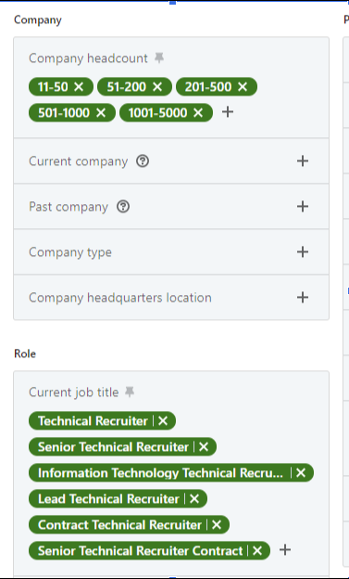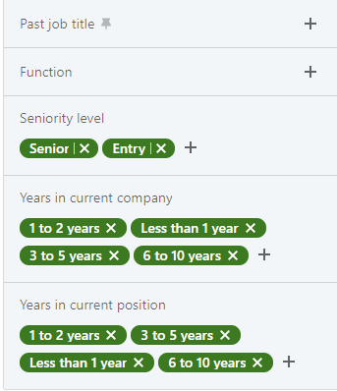
Use LinkedIn Sales Navigator to select leads that align with your experience and industry:
- Apply filters to generate ~60,000 leads, then narrow down to ~1,000 by focusing on:
  - Leads who posted in the last month.
  - Posts containing specific keywords (e.g., Angular, React, Frontend).
  - Recruiters in tech hubs like San Francisco or LA for high-level tech roles.
Step 2: Automate Outreach with Zopoto
- Export your lead list to Zopoto to automate connection requests and messages.
- Test different opening messages (A/B testing) to optimize response rates (aim for 20–25%).
- Keep messages short, relevant, and tailored to convince recruiters you’re the perfect candidate. Avoid extraneous details, as recruiters are motivated to place you.
- Example: Draw inspiration from the author’s recent recruiter conversation (not fully optimized, so adapt rather than copy).
Step 3: Manage Responses and Schedule Calls
- Zopoto will generate responses from recruiters eager to chat.
- Use Calendly to streamline scheduling, especially if managing a busy schedule or multiple interviews.
- Engage with as many recruiters as possible to secure interviews (C2C, 1099, or W-2).
Key Tips
- A/B test your messages to find the highest-converting approach.
- Use a new LinkedIn account for safety.
- Calendly is invaluable for managing a busy interview schedule.
- 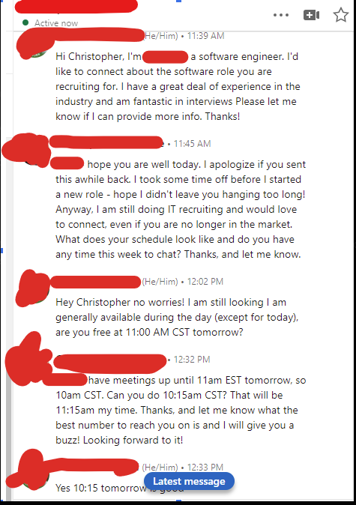
With this funnel, your LinkedIn inbox will soon be flooded with recruiters ready to set up interviews. Follow these steps, and you’ll be well on your way to landing 5+ interviews weekly.

LinkedIn Profile Optimization Guide for Recruiter Search
With over 3 years of experience, LinkedIn can be a powerful tool to get your resume noticed by optimizing your profile for recruiter searches via LinkedIn Sales Navigator. This guide will show you how to rank highly in recruiter searches, what recruiters filter by, and tricks to enhance your visibility. By optimizing your profile, you can ensure it appears at the top of recruiter search results, significantly boosting your job search.
Understanding Recruiter Search Filters
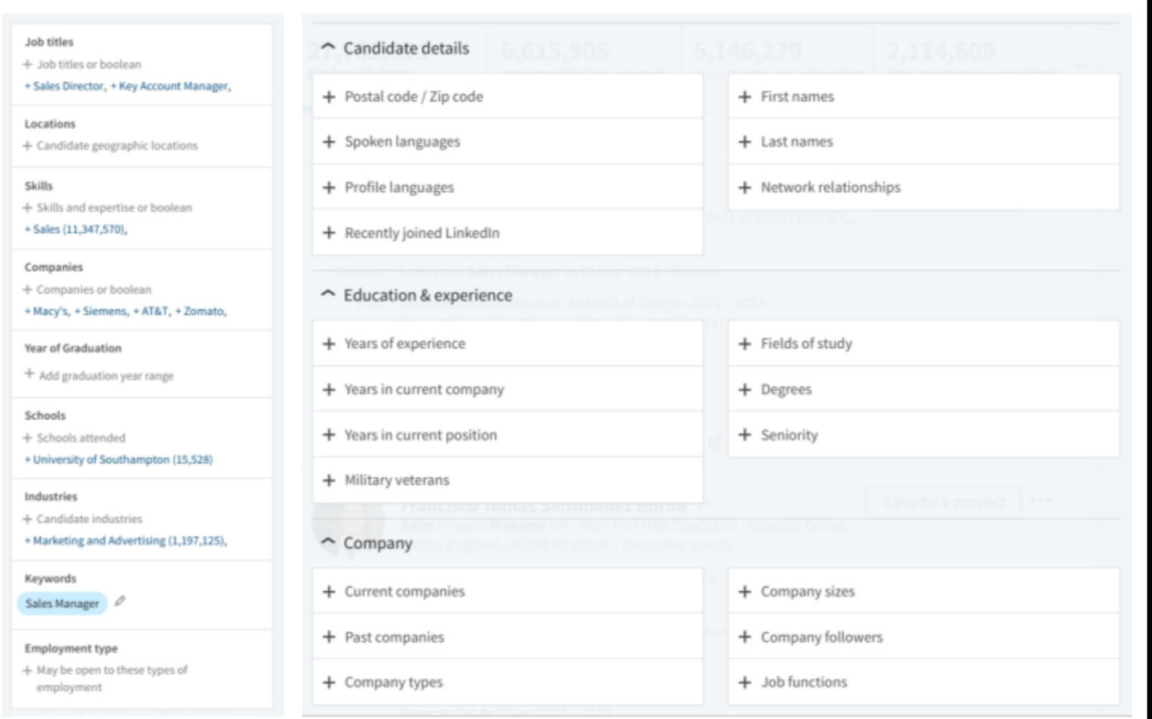
Recruiters use LinkedIn Sales Navigator to find candidates. Your goal is to stay within their search filters so they can find your profile, access your public resume, and contact you via phone, email, or LinkedIn messages. Below are the key sections to optimize:
1. Job Title & Headline
- Use the most common, transferable job title for your role, even if it differs from your official title.
- Avoid overly complicated or lengthy titles.
- If your title is generic, add a specialization or vertical (e.g., “Account Manager, Luxury” or “Software Engineer, Machine Learning”).
- Goal: Capture as many relevant searches as possible.
2. Skills
- Skills narrow searches to specific expertise. Include:
  - Core functional skills (e.g., “Business Development,” “Project Management”).
  - Languages, software, and programming languages (e.g., “Python,” “Illustrator”).
  - Soft skills (e.g., “Communication,” “Problem Solving”).
- Add all relevant skills matching your background.
- Include languages (e.g., English), as omitting them may exclude you from searches.
3. Years of Graduation
- Recruiters use this to estimate age and seniority.
- List an educational background, even if you haven’t completed a degree, to stay in searches that filter by graduation year.
- Omitting this field will exclude you from any search using this criterion.
4. Industry
- Though not displayed publicly, industry is a commonly used filter.
- Choose an industry (e.g., “Consumer Goods”) or function (e.g., “Accounting”) that aligns with your target roles.
- If breaking into tech, set your industry to the relevant tech sector (e.g., see LinkedIn Industry List).
Additional Optimization Tips
1. Get on the “Hot” List
LinkedIn prioritizes profiles likely to respond in a separate “hot” list, ensuring recruiters contact these candidates first:
- Profile Picture: Use a professional headshot. A photo of you speaking publicly is also effective.
- Background Image: Choose an image related to your field (e.g., computers for tech roles).
- Profile Summary: Write a concise elevator pitch. Example for a Data Analyst:
Hello! Thanks for stopping by. I'm an enthusiastic Data Scientist and Machine Learning Specialist, experienced in crafting data-driven solutions with Python, SQL, and cloud computing. Currently, I'm expanding my knowledge while pursuing an M.Sc. in Analytics at M.I.T. I thrive in Agile teams, pushing data insights to enhance performance. If you're as excited about the potential of data science as I am, let's connect and chat!
2. Experience Section
- Your LinkedIn profile is not a resume. Focus on highlighting your strongest technologies and job titles.
- Avoid listing extensive accomplishments or metrics (e.g., percentages).
- Example:
Developed various software solutions for a game development company using Python, Spark, SQL, Pandas, and Looker; this included deploying a logistic regression model to boost in-app purchases and improving user experience through a Bayesian inference-based multi-arm bandit strategy.
- Fill out all jobs with relevant technologies and keywords.
3. Final Steps
- Set your profile to “Open to Work” and make your resume searchable by recruiters.
- Add every relevant technology and keyword to your skills section.
- Update your profile weekly to signal activity, increasing the likelihood of recruiter messages (inactive profiles still receive inbound, but active ones get more).
Expected Results
By following these steps, you can expect 2–3 LinkedIn inbound messages daily and several calls from recruiters weekly, significantly enhancing your job search success.

